**Lab: File path traversal, traversal sequences stripped with superfluous URL-decode**

Problem: The application blocks input containing path traversal sequences. It then performs a URL-decode of the input before using it.

Goal: retrieve the contents of the /etc/passwd file.

Solve:

1-

2-encode🡪decode url

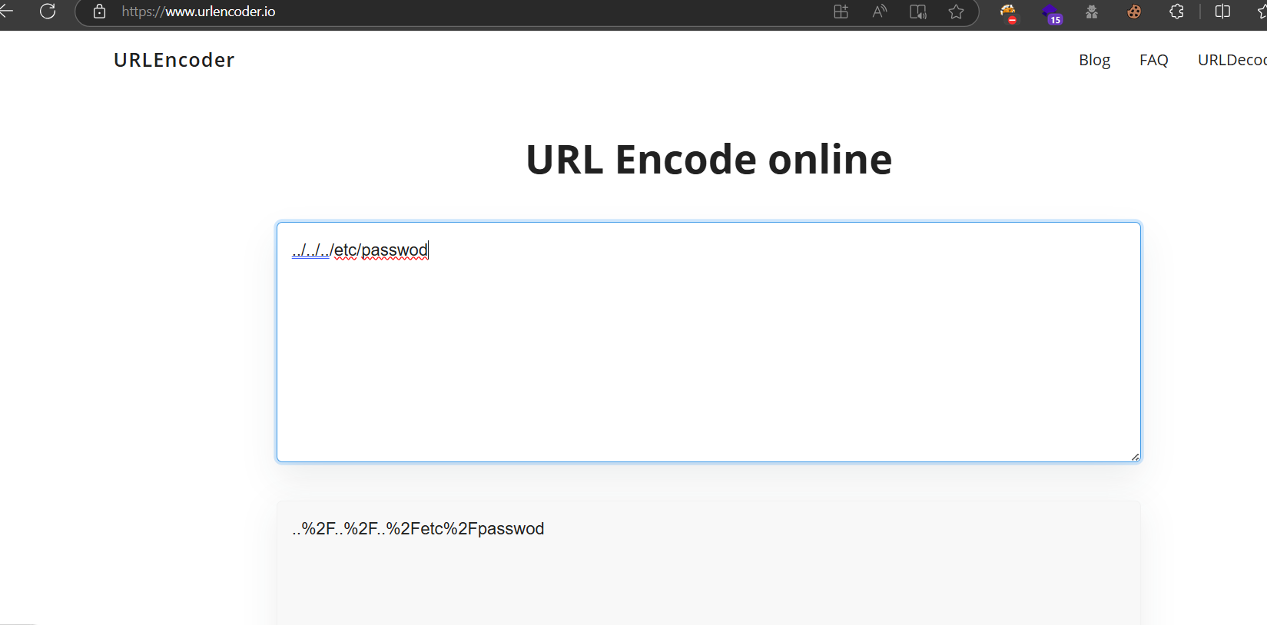

3-

4-

5-

